**Homework – Lab 3**

**Name: Fabian LeFevre**

1) Ensure you’ve taken all required screenshots and put them where requested throughout the lab manual.

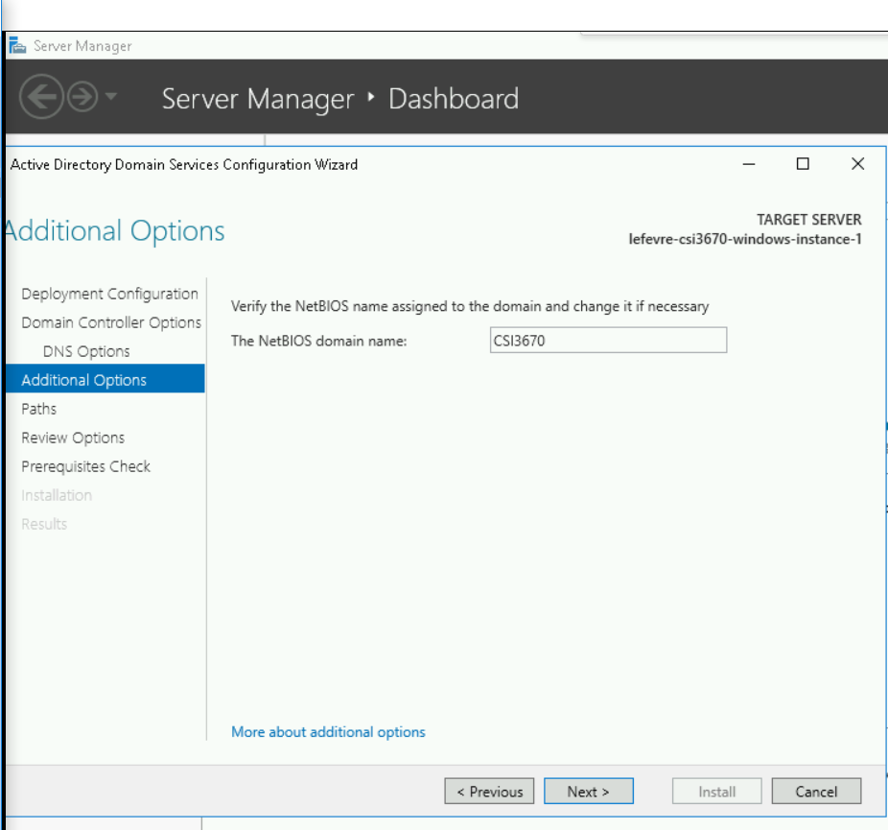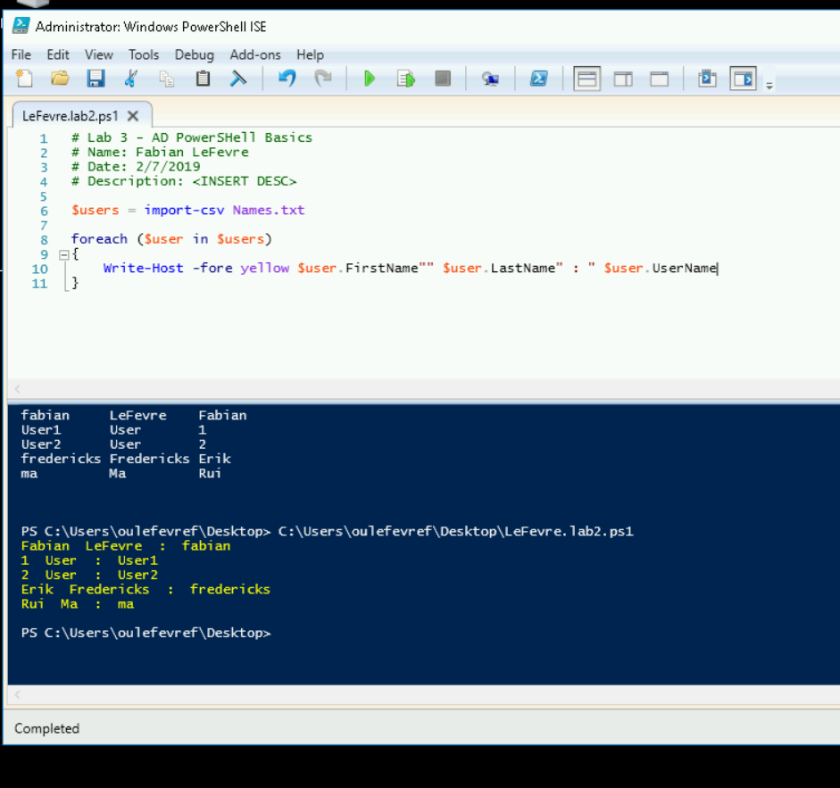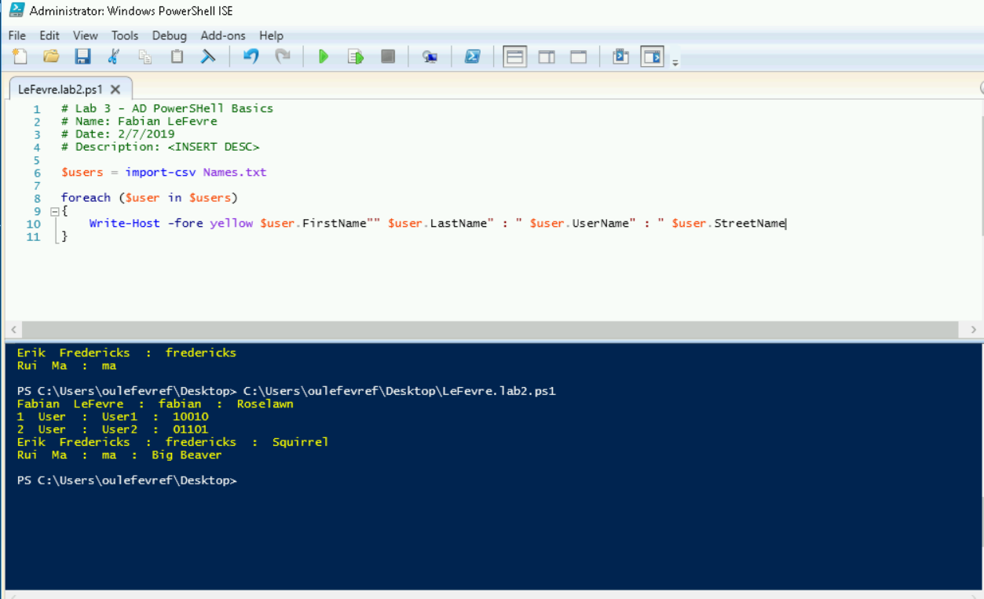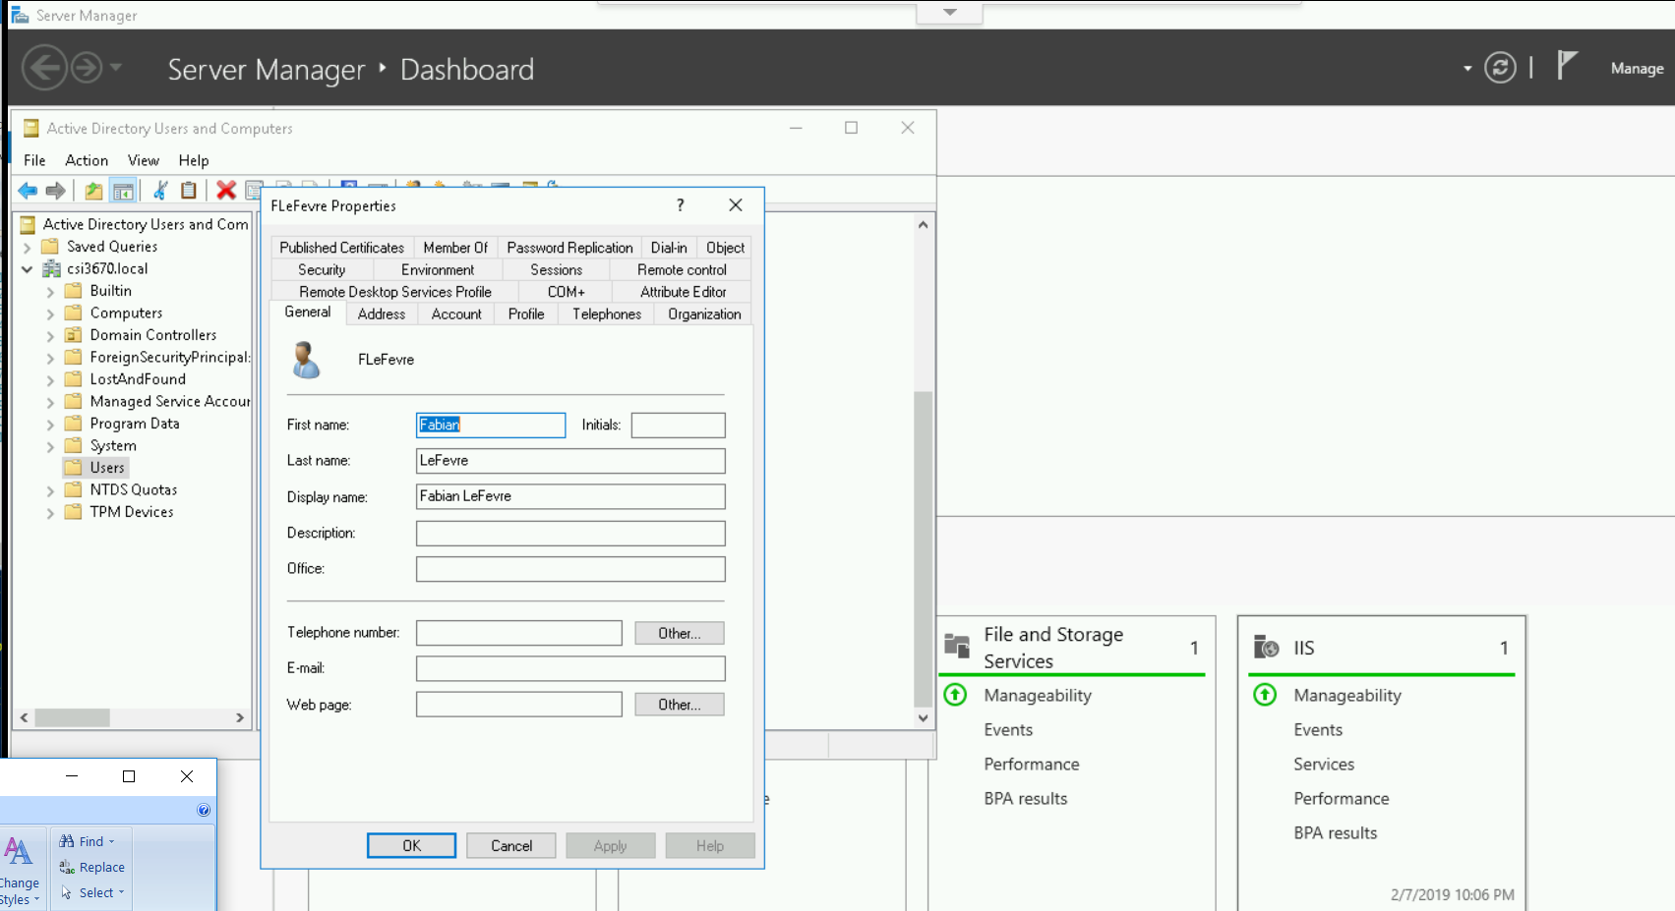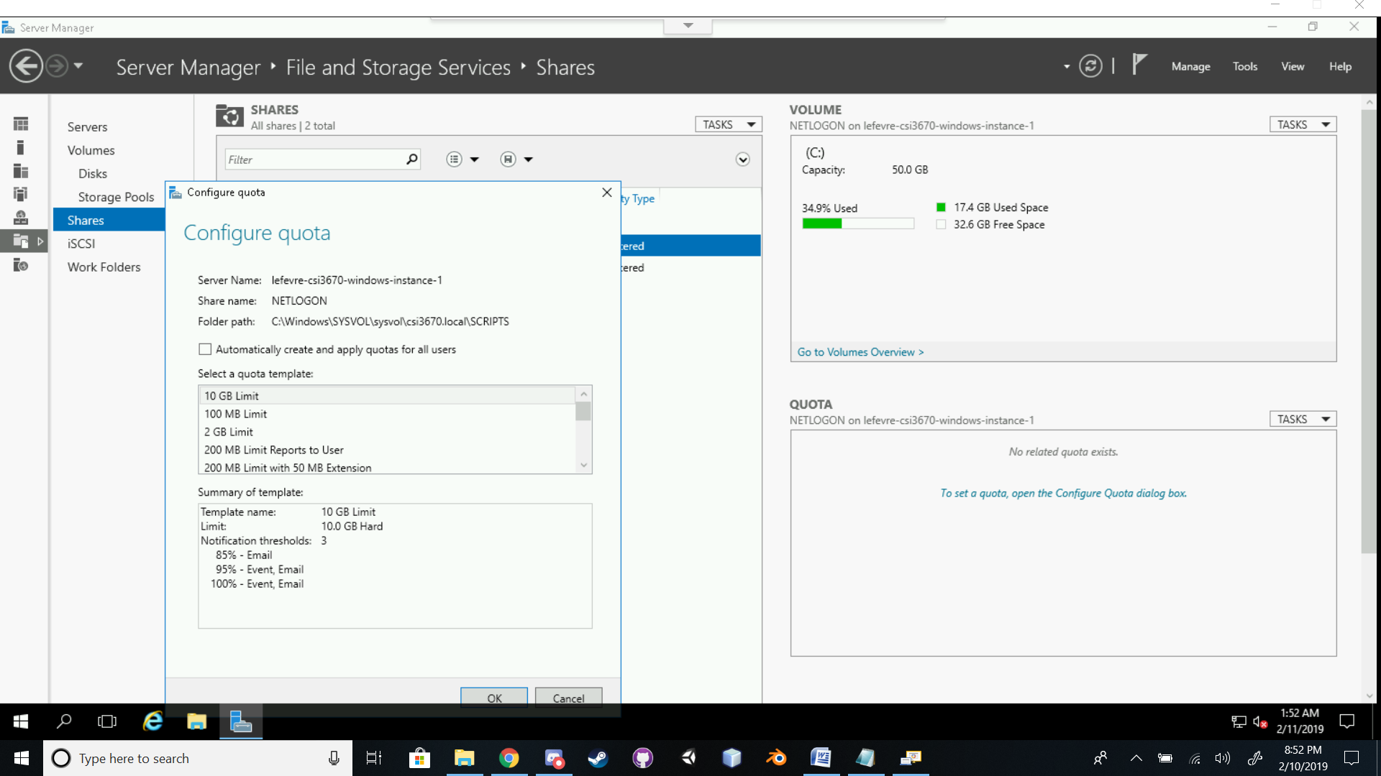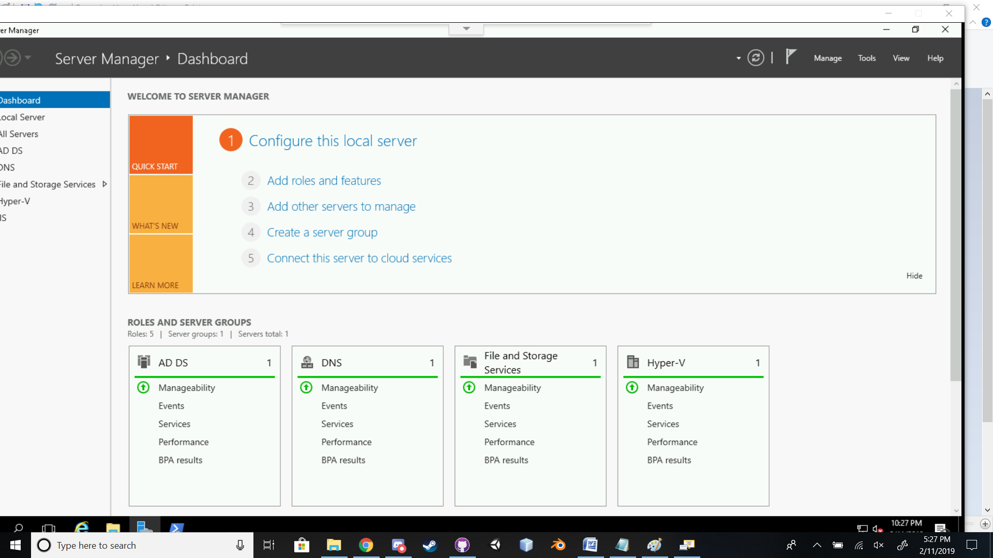

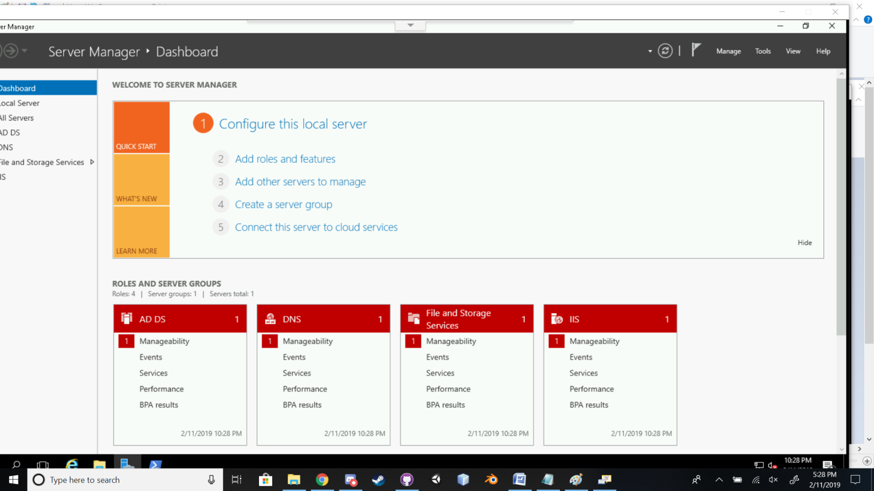

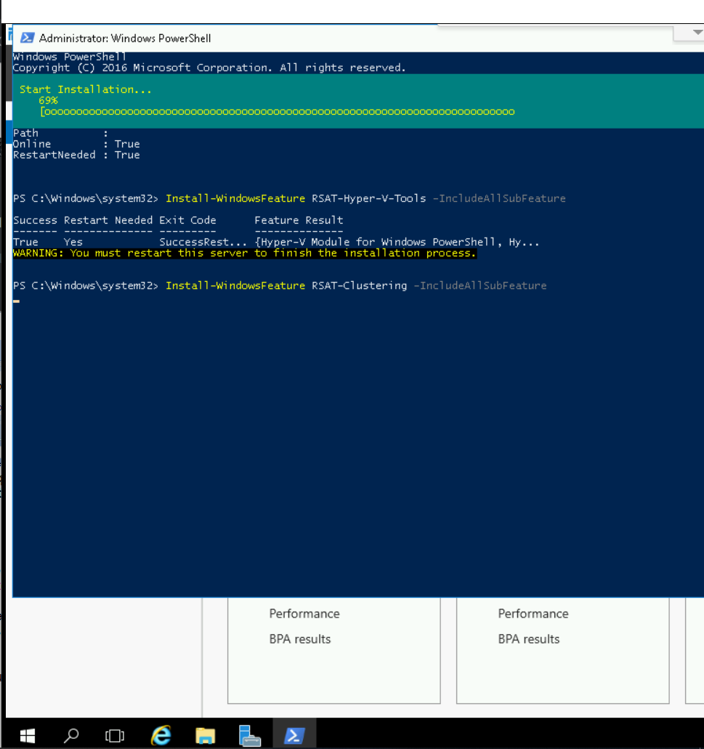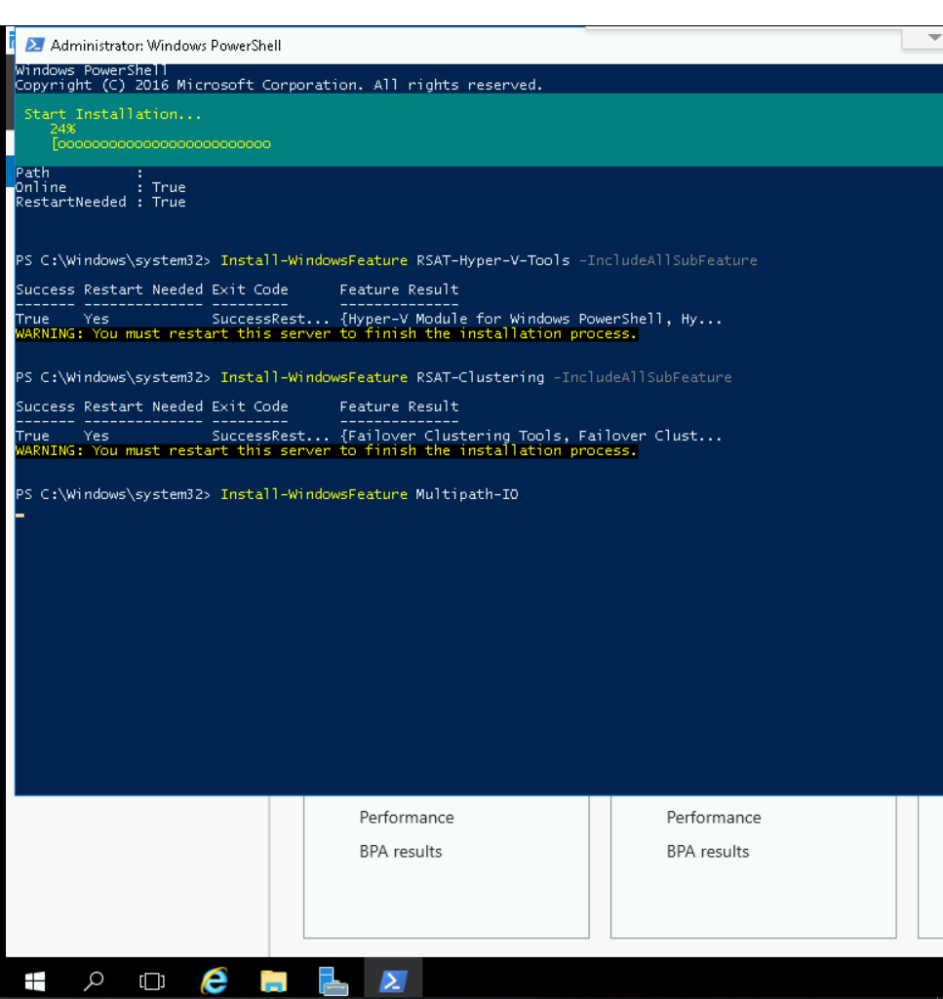

2) What is the purpose of having multiple domain controllers per domain? In more detail, explain what Active Directory does between domain controllers within a domain?

**The point of having multiple domain controllers is to ensure reliability of the Domain. If one domain controller is offline or stops functioning, other domain controllers can be utilized and take over. This also will help performance of the domain and better organize groups within the domain.**

**What AD does with the domain controllers in a domain are store and maintain a copy of the AD database, user account maintenance, ensure unique domains, manage schema, allow database replication, manage infrastructure for the domain controllers, and manage the domain controllers’ security protocols throw Relative IDs and GUIDs.**

3) What is your server's distinguished name?

**DC=csi3670,DC=local**

4) Describe your PowerShell script output.

**The script created new users based on the parameters of the Names.txt file and the variables created and assigned in the script that were passed to the New-AdUser command line. This line was either creating new Admin users or just creating New Users onto the system or domain. The WhatIf flag displayed what the script is currently doing in the New-AdUser command.**

5) What is the purpose of the command run in the lab (Get-ADUser efredericks -Properties memberof)

**PS C:\Users\oulefevref\Desktop> Get-ADUser efredericks -Properties memberof**

**DistinguishedName : CN=EFredericks,CN=Users,DC=csi3670,DC=local**

**Enabled : True**

**GivenName : Erik**

**MemberOf : {}**

**Name : EFredericks**

**ObjectClass : user**

**ObjectGUID : 8ddc5352-b448-4947-900b-ab27c69be490**

**SamAccountName : EFredericks**

**SID : S-1-5-21-1593496284-243477520-438830787-1107**

**Surname : Fredericks**

**UserPrincipalName : EFredericks**

**Display the information and parameters of the User “efredericks”.**

6) Output of the Get-ADUser second run.

**PS C:\Users\oulefevref\Desktop> Get-ADUser efredericks -Properties memberof**

**DistinguishedName : CN=EFredericks,CN=Users,DC=csi3670,DC=local**

**Enabled : True**

**GivenName : Erik**

**MemberOf : {CN=Administrators,CN=Builtin,DC=csi3670,DC=local}**

**Name : EFredericks**

**ObjectClass : user**

**ObjectGUID : 8ddc5352-b448-4947-900b-ab27c69be490**

**SamAccountName : EFredericks**

**SID : S-1-5-21-1593496284-243477520-438830787-1107**

**Surname : Fredericks**

**UserPrincipalName : EFredericks**

7) Why can’t we run a hypervisor within a hypervisor?

**We can’t run a hypervisor within a hypervisor because we are not using Windows Server 2016 or later and the machines are not configured properly or have the components necessary to support it.**

8) Assume we’re actually going to create a real environment. Modify the New-ADUser cmdlet from the script above to include a **Street Address, Phone Number, Email Address, Job Title, and membership in the Administrators group**. Note that ‘clicking the GUI’ is not an acceptable answer → it must be a full PowerShell command. To test it, you can either delete the users you've created in ADUC or you can change the usernames to be distinct.

**Extra credit**) With a partner, try to add each other's machines to your Active Directory listing. To do this, you'll need to look into VPC networks, add each other to your GCP projects, etc. Describe the process you took to do it and show me screenshots of your machines in each others' server listing.

Zip up your script and Names.txt file and submit it along with this handout. I’ll be checking your comment block as well, so make sure that you’ve updated it appropriately. Points will be lost if I see any boilerplate text (<your name> for instance)

**WEBSITE USED FOR REFERENCE:**

[**https://www.manageengine.com/products/ad-manager/help/csv-import-management/active-directory-ldap-attributes.html**](https://www.manageengine.com/products/ad-manager/help/csv-import-management/active-directory-ldap-attributes.html)